**Name:** Rameen **Roll No:** 2023-EE-03

EE-322L Analog and Digital Communication Marks Obtained: ________

**Lab Report**

**Experiment No. 5**

**Envelope Detection**

**Note:**

* **Don’t forget to include the two rubrics tables (available at the end in this document), otherwise reports will not be graded.**
* **Copy-pasted and plagiarized reports will get zero marks**

1. **Objective**

The objective of this experiment is to **demodulate an Amplitude Modulated (AM) signal using an envelope detector**. The aim is to recover the original message signal from the modulated carrier by designing and implementing a diode–RC envelope detector circuit, and to analyze how the time constant (RC) affects the accuracy of signal reconstruction.

1. **Technical Background**

Amplitude Modulation (AM) varies the amplitude of a high-frequency carrier according to the message signal. The modulated signal can be written as:

**s(t) = [$A_{c}+m\left(t\right) ] cos⁡(w_{c}t)$**

To recover the message, **envelope detection** is used when the modulation index μ<1μ < 1μ<1. The **envelope detector** consists of a diode and an RC circuit. The diode rectifies the AM signal, while the RC network filters and tracks its envelope. The **RC time constant** must be chosen carefully, large enough to remove carrier ripples but small enough to follow the envelope accurately. Envelope detection is a simple and effective method commonly used in **AM radio receivers** for demodulation.

1. **Task-1**
   1. ***Description***

Generate the AM signal as done in previous experiment and make sure that the modulation index is less than 1.

* 1. 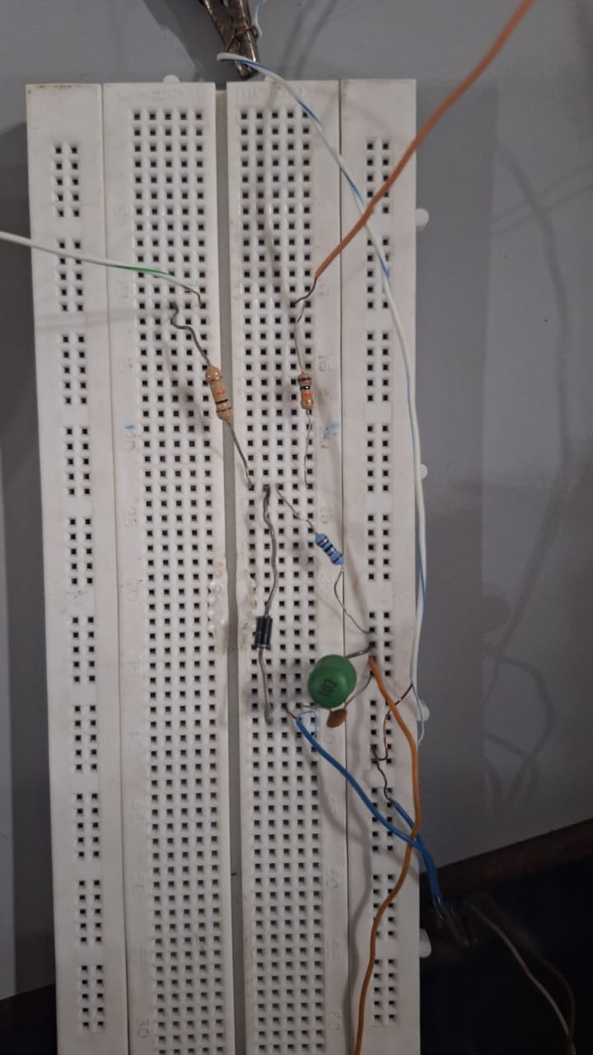***Circuit, Design and Calculations***

The amplitude of the message signal was kept lower than the carrier signal, so that the modulation index was less than 1.

* 1. ***Results and Discussions (with all graphs and snaps)***

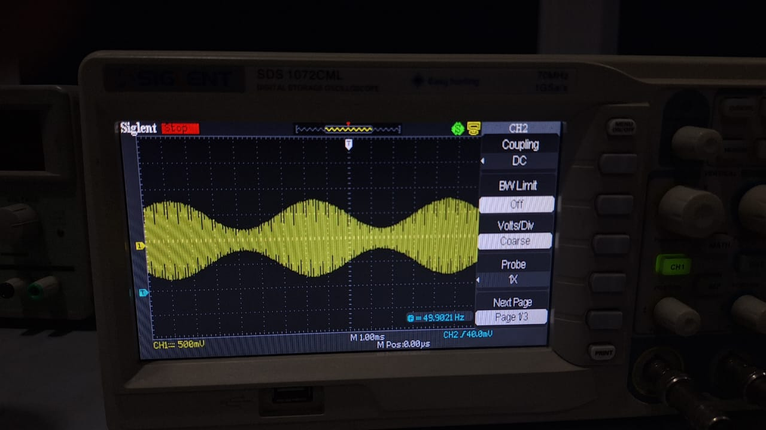

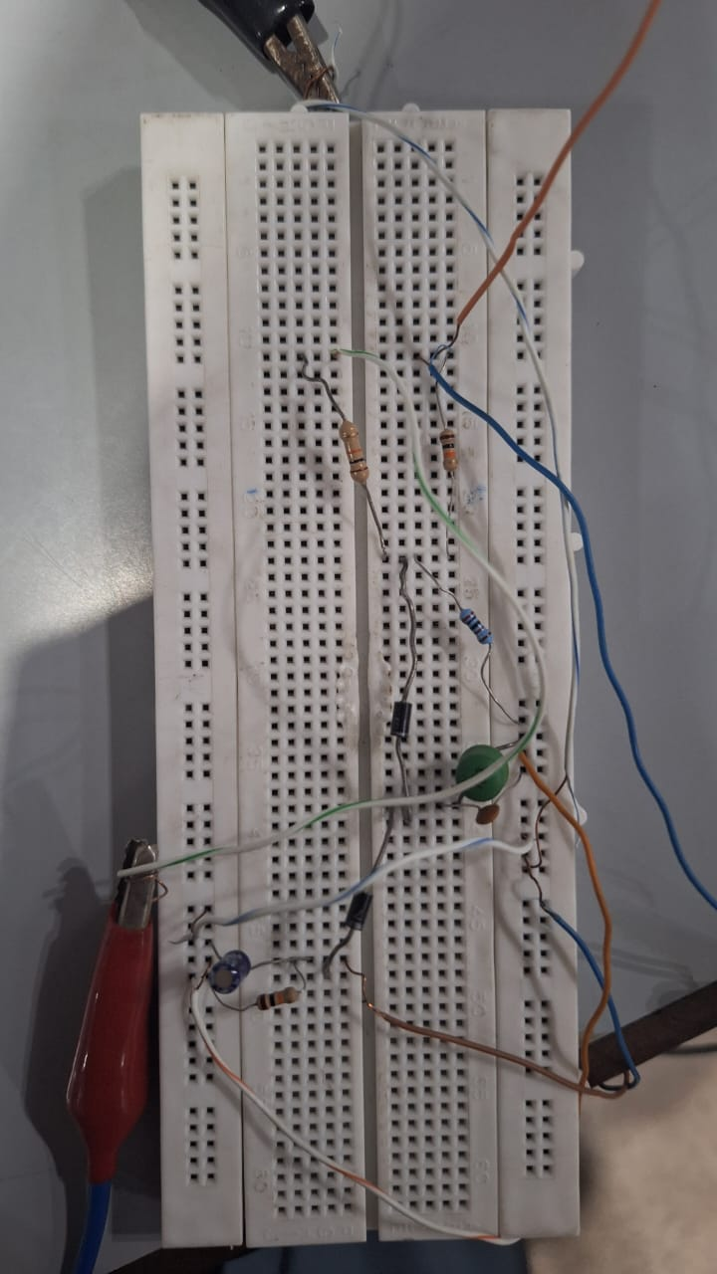

1. **Task-2**
   1. ***Description***

Place a diode followed by a RC circuit to recover the envelop of the AM signal. Design the values of time constant RC so that the demodulated signal closely follows the envelope of AM signal, then implement the circuit on breadboard and observe the output.

* 1. ***Circuit, Design and Calculation***
  2. ***Results and Discussions (with all graphs, and snaps)***

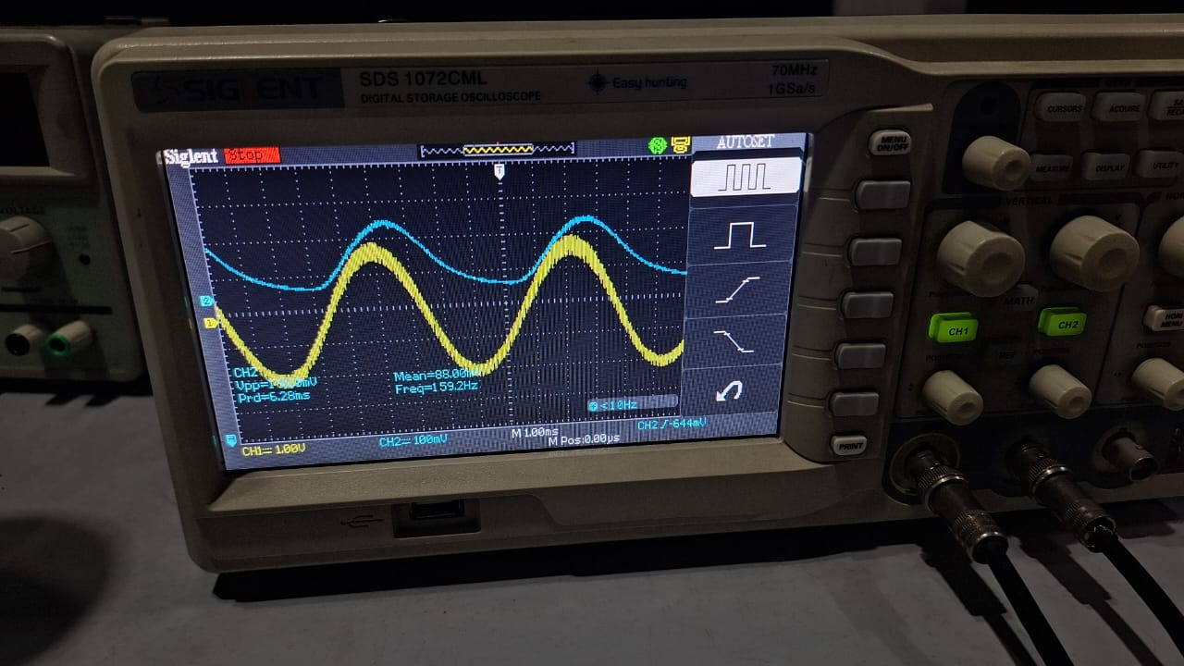 **Message signal + demodulated signal:**

On the above snapshot, the yellow signal is the message signal and the blue signal is the demodulated signal.

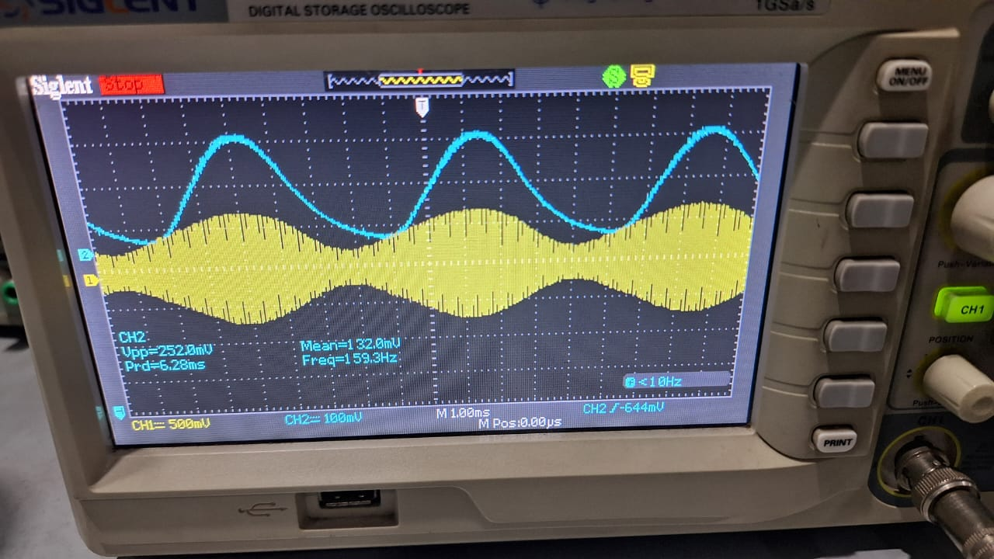**Modulated signal + demodulated signal:**

On the above snapshot, the yellow signal is the modulateds signal and the blue signal is the demodulated signal.

1. **Task-3**
   1. ***Description***
   2. ***Circuit, Design and Calculations***
   3. ***Results and Discussions (with all graphs and snaps)***
2. **Conclusion**

**Rubrics for Experiment No.**

|  |  |  |  |  |
| --- | --- | --- | --- | --- |
| **Performance** | **Exceeds expectation (2)/(1)** | **Meets expectation (1)/(0.5)** | **Does not meet expectation**  **(0.5)/(0)** | **Marks** |
| **R1: Realization of Experiment’s Hardware on Breadboard.**  **Marks: 0-1** | The circuit is patched correctly, and safely, with neat  connections on the breadboard | The circuit is  patched neatly and correctly, but not in a workable form | Incapable to patch the circuit correctly and  neatly on breadboard |  |
| **R2: Knowledge of theoretical aspects**  **Marks: 0-2** | Has theoretical knowledge required for the experiment | Has partial theoretical knowledge about the experiment | Has no background knowledge about the experiment |  |
| **R3: Conducting Hardware**  **Experiment.**  **Marks: 0-1** | All the required tasks are correctly implemented | The required tasks are partially implemented | Unable to implement all the tasks even with guidance |  |
| **R4: Demonstrate proper results with justification.**  **Marks: 0-2** | Correct results are provided with required justification | Results are provided with  minor errors and/or with little  justification | Results are provided with major errors  and/or with no justification |  |

**Rubrics for Lab Manual No.**

|  |  |  |  |  |
| --- | --- | --- | --- | --- |
| **Performance** | **Exceeds expectation (0.5)/(0.25)** | **Meets expectation (-)/(-)** | **Does not meet expectation (0)/(0)** | **Marks** |
| **R1:** Timely submission  **Marks: 0-**  **0.25** | The submission is on  time | --- | Late submission |  |
| **R2:** Report completenes s  **Marks: 0-0.5** | All relevant calculations, specifications, code, graphs, and results are provided with proper  explanation. | All the relevant calculations,  specifications, code, graphs and results  are provided but with little  explanation and justification. | Most of the relevant graphs, results,  calculations, specifications, and code are missing, as well as their proper  explanation and  justification is also missing. |  |
| **R3:** Error-  free writeup  **Marks: 0-**  **0.25** | The submitted  assignment is without any plagiarism and formatting errors. | Some parts of the submitted  assignment contain formatting errors and plagiarized material. | The submitted assignment is mostly plagiarized and contain formatting errors. |  |